New YouTube videos explain Graphene for the baffled
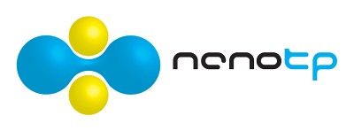
In October the Nobel Prize for Physics was awarded to two researchers from Manchester University for their work on Graphene. But if, like much of the world, you’re left wondering just what graphene is, and why it deserves a Nobel Prize, then help is at hand. With the aid of science video communication charity, The Vega Science Trust, the COST Action MP0901 “NanoTP” has produced two short videos explaining graphene and its amazing properties. The videos are written and presented by Jonathan Hare, and show how amazingly graphene can be produced using just a pencil and some sticky tape. Jonathan has previously appeared in BBC Science programmes such as “Rough Science” and now runs the Creative Science Centre in Sussex ─ Watch the videos on the web at www.nanotp.org, www.vega.org.uk, AthenaWeb, or directly from www.youtube.org/vegasciencetrust.

“The Nobel prize was a surprise that couldn’t be more timely for us – Graphene is a wonderful material that’s been on the ‘wish list’ of theoretical science for a long time before it actually existed”, says Carla Bittencourt, chair of NanoTP. “It’s a great playground for the scientists in our project. Tools that we’ve developed to study other forms of carbon like nanotubes are all in place, it means graphene will rapidly make the transition from basic science to real-world applications. I hope that awarding the prize to Graphene will call the attention of funding agencies to the importance of ‘scientific curiosity’ in the centre of research projects”.

NanoTP is a network funded since the start of 2010 by COST (European Cooperation in Science and Technology); it has over 150 scientists from 24 different countries working in the field of nanotechnology. “NanoTP brings together scientists from across Europe, America and Asia, to pool resources and ideas, and cross geographical and scientific borders”, says Chris Ewels, vice-chair of NanoTP. “For us it’s important to communicate with the public. People want to know about nanoscience and its implications for the future, and as scientists working in this area we have a responsibility to get involved in the public debate”.

Links:
COST Project MP0901: NanoTP website: http://www.nanotp.org
The Vega Science Trust http://www.vega.org.uk
The Graphene videos on YouTube: http://www.youtube.com/vegasciencetrust
Jonathan Hare’s Creative Science Center: http://www.creative-science.org.uk

Contact:
Dr Chris Ewels chris.ewels@cnrs-imn.fr Tel : +33 240 37 64 07
The Vega Science Trust:
Gill Watson g.e.watson@vega.org.uk Tel : +44-1273-678726
Images: Available free for use, copyright mark as below please


COST Logo


NanoTP Logo Vega Science Trust logo
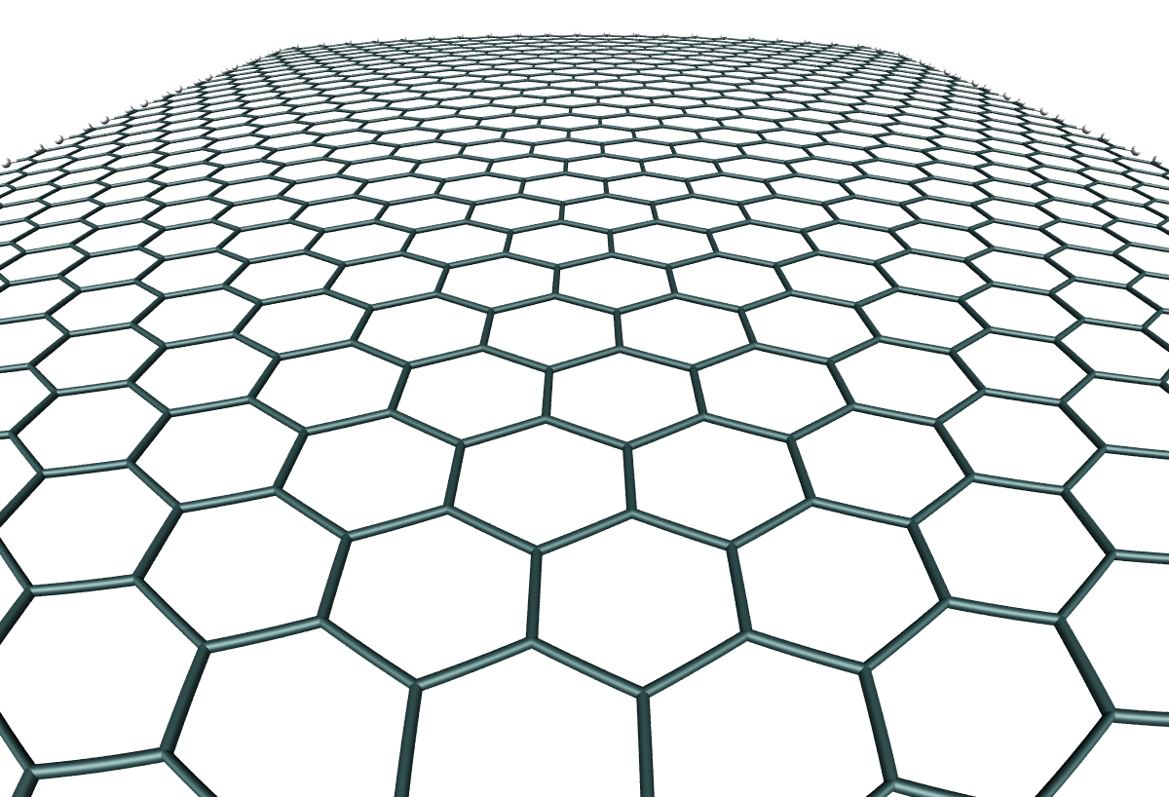
Structure of Graphene. Image ©www.ewels.info

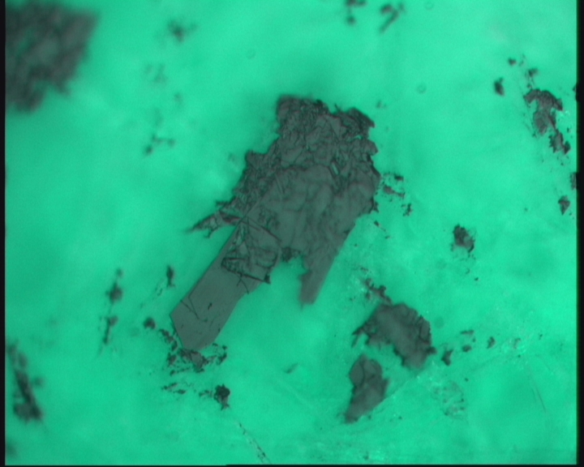
Drawing on paper with a pencil deposits flakes of graphite (seen here magnified 2000 x times), as well as single layers of graphite – graphene. (EMAT – L.Roussou and C. Bittencourt)
Image © NanoTP www.nanotp.org

The Vega Science Trust is a UK not-for-profit organisation set up in 1995 to promote science by Sir Harold Kroto (Nobel Laureate for the discovery of C60 in 1996). Over the past 15 years the Vega Science Trust has produced and streamed science videos, including interviews with Nobel Laureates to millions of viewers and received prizes for its website and videos. The Graphene videos are part of a series of extremely successful films used in school workshops and informal education environments aimed at the general public.

